3.13 Missing Data Example Solution
The data are visualised in figure 0, showing the missing data pattern. There is most missing data for Q3 and Q5.
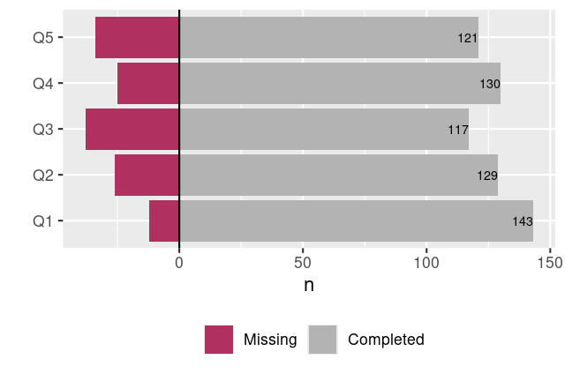
Figure 0: Missing data chart

The LIKERT data, without imputations of the missing data values, is visualised below in bar chart, heat map, and histogram form:
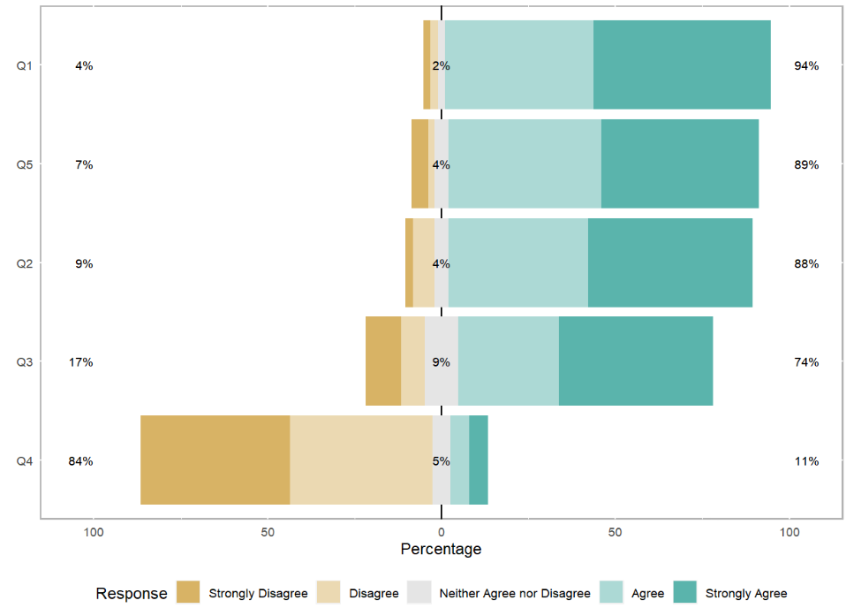
Figure 1: LIKERT bar chart of the survey results

All three visualisations (figure 1, figure 2) indicate that generally customers choose this supermarket for financial reasons. They appreciate the discounts and special offers, and believe these are worth any extra expenses incurred in travelling to this supermarket over a closer one.
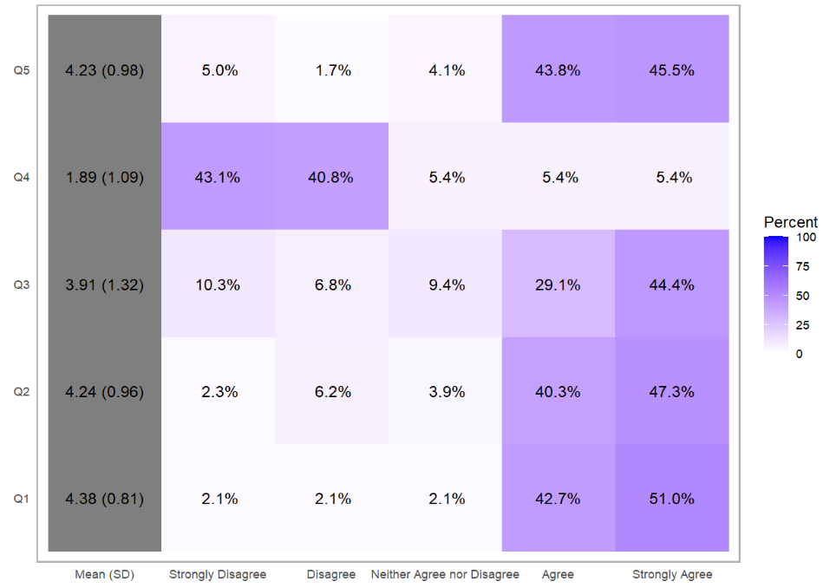
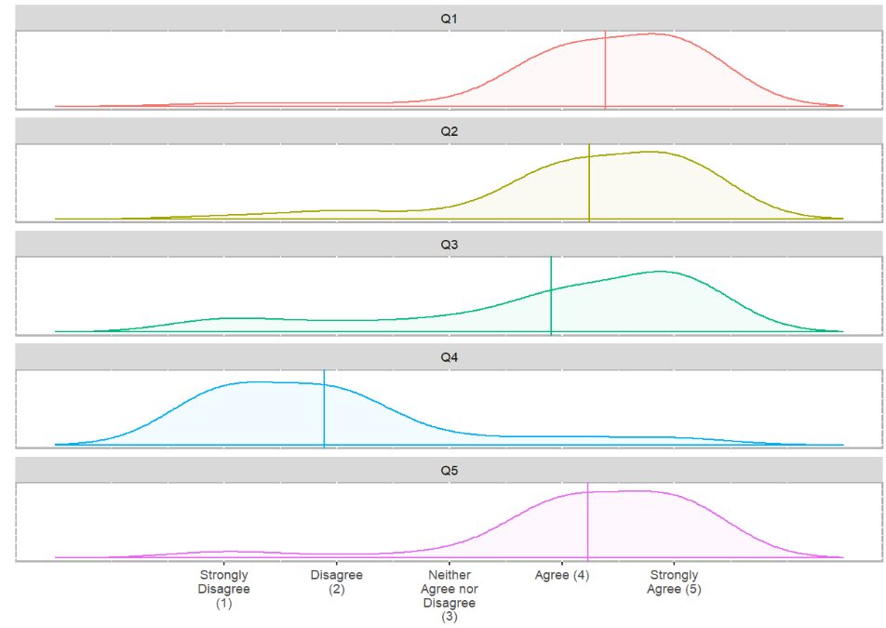
Figure 2: Heat plot (above) and histogram (below) of LIKERT responses.
Visualising the missingness of the data, we see that around 17% of data in total is missing, with question 1 having the least missingness (8%) and question 3 the most (25%).
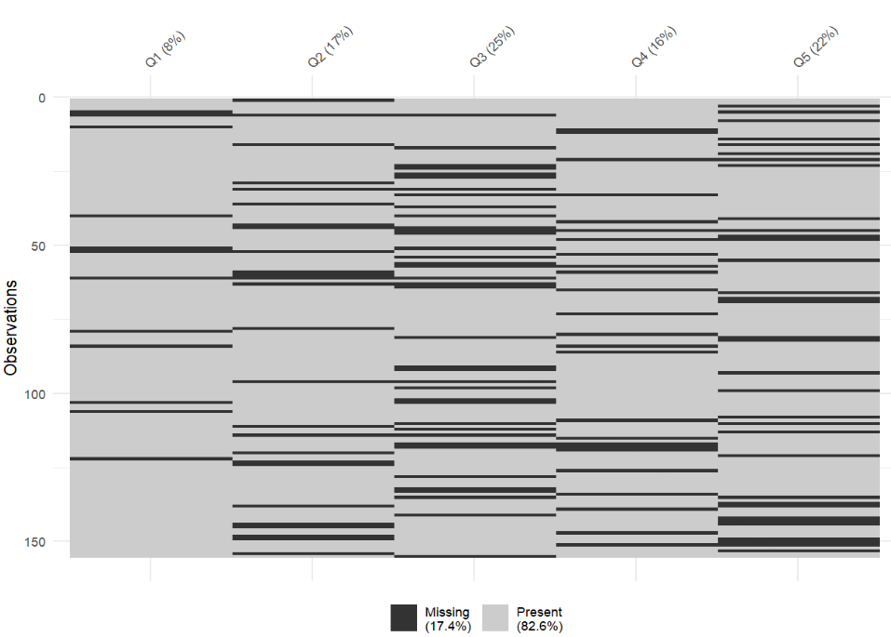
Figure 3: Missing data plot showing levels of missingness of each question, and in the dataset as a whole.
An MCAR test on the data, omitting the id column in column 1, found that the data can be considered missing completely at random (p=0.66).
Imputation methods were then applied to the dataset.
Mean Imputation
The mean value was imputed for each missing datapoint. Using question 3 to assess imputations, it can be seen that the distribution looks different comparing densities (figure 4), and we can see (in the data) that the imputed value for all missing data was 3.91 with a corresponding peak near to 4 in the density plot and a step up at that value in the edf plot.
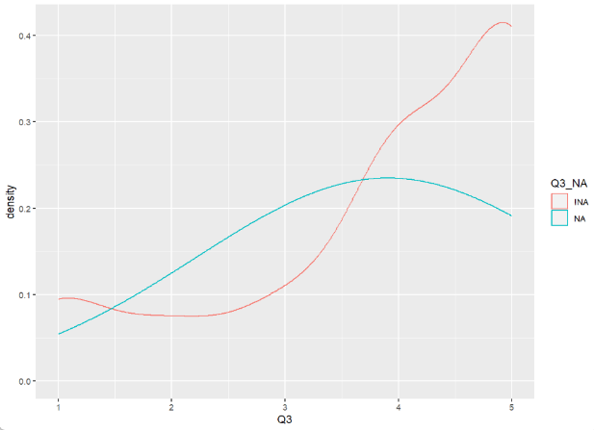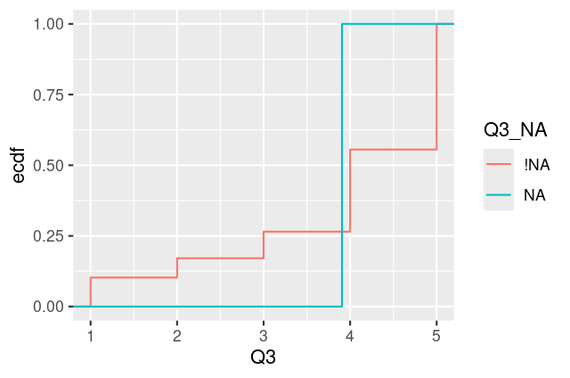
Figure 4: Density plot of question 3 using the original data (in red) and the mean imputed data (cyan), and corresponding EDF plots.
Regression Imputation
Looking at the density plot, it can be seen that the distributions of the missing data and original data more closely align, however there are slightly more higher values than in the original dataset, seen in the double peaks. Comparing edfs reveals that the majority of the data is imputed in the middle to high values, corresponding to the peaks seen in the density plot. While not all data are integers, the edfs converge at higher values (Figure 5).
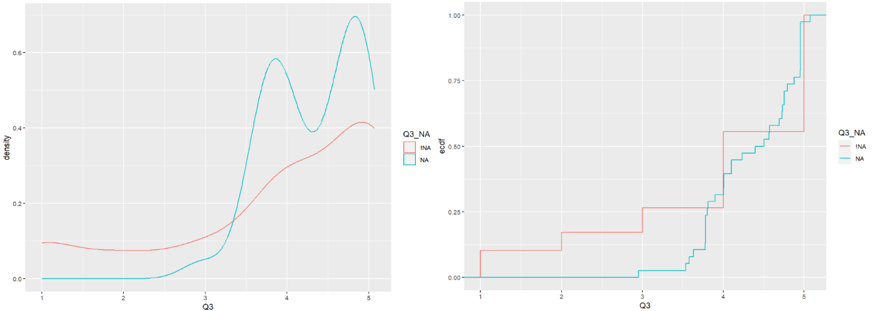
Figure 5: Density plot and EDF graphs comparing the observed and imputed values using regression imputation.

Predictive Mean Matching
Looking at the density of observed and imputed values, the PMM imputation distribution follows the observed data quite closely until the upper extremities where there are more high values in the imputed data. Comparing EDFs, we can see that there is a slightly lower proportion of lower values imputed than were observed in the dataset, and proportionally more higher values imputed than in the observed data.
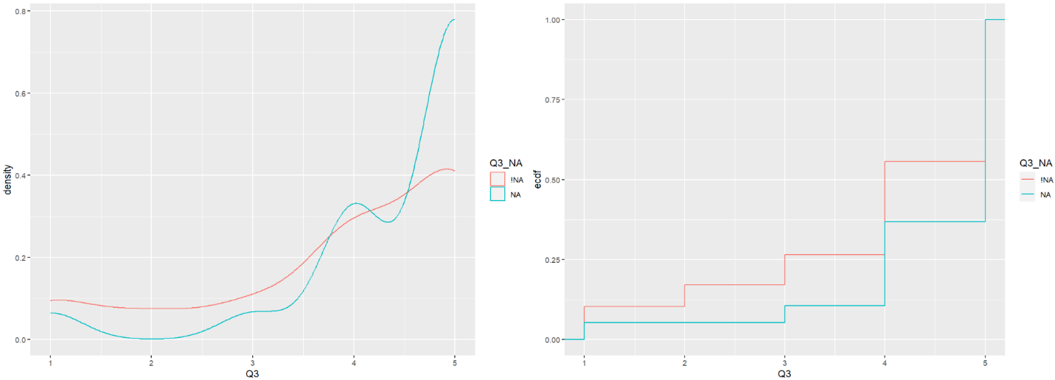
Figure 6: Density plot and EDF graphs comparing the observed and imputed values using predictive mean matching.

Example Code
# Read in data #
data=read.csv("Shopping survey.csv")

# Convert to factors for LIKERT functions #
data$Q1=factor(data$Q1, labels=c("Strongly Disagree", "Disagree", "Neither Agree nor Disagree", "Agree", "Strongly Agree"))
data$Q2=factor(data$Q2, labels=c("Strongly Disagree", "Disagree", "Neither Agree nor Disagree", "Agree", "Strongly Agree"))
data$Q3=factor(data$Q3, labels=c("Strongly Disagree", "Disagree", "Neither Agree nor Disagree", "Agree", "Strongly Agree"))
data$Q4=factor(data$Q4, labels=c("Strongly Disagree", "Disagree", "Neither Agree nor Disagree", "Agree", "Strongly Agree"))
data$Q5=factor(data$Q5, labels=c("Strongly Disagree", "Disagree", "Neither Agree nor Disagree", "Agree", "Strongly Agree"))

library(likert)
results=likert(data[, 2:6]) # supply the data, omitting the id column which is not a factor
likert.histogram.plot(results) # missing data

plot(results, type="bar")
plot(results, type="heat")
plot(results, type="density")

# revert to numeric columns for functions below

data$Q1=as.numeric(data$Q1)
data$Q2=as.numeric(data$Q2)
data$Q3=as.numeric(data$Q3)
data$Q4=as.numeric(data$Q4)
data$Q5=as.numeric(data$Q5)

# Missing data

require(tidyverse)
require(mice)
require(naniar)
library(simputation)
library(dplyr)

data1<-data[,2:6] # store data without id label
vis_miss(data1)
mcar_test(data1)

#Shadow Matrix

as_shadow(data1)
shadow_data=bind_shadow(data1)

# Mean Imputation #

imp_mean = complete(mice(shadow_data, method = "mean", m = 1, maxit = 1))

ggplot(imp_mean,
aes(x = Q3,
colour = Q3_NA)) +
geom_density()

# Assess Using EDF

imp_mean %>%
ggplot(aes(x = Q3,
colour=Q3_NA)) +
stat_ecdf()

# Regression Imputation

data2=complete(mice(shadow_data, method="norm.predict", m=1, maxit=1))

ggplot(data2,
aes(x = Q3,
colour = Q3_NA)) +
geom_density()

# Assess Using EDF

data2 %>%
ggplot(aes(x = Q3,
colour=Q3_NA)) +
stat_ecdf()

#PMM

data3=complete(mice(shadow_data, method="pmm", m=1, maxit = 1))

ggplot(data3,
aes(x = Q3,
colour = Q3_NA)) +
geom_density()

data3 %>%
ggplot(aes(x = Q3,
colour=Q3_NA)) +
stat_ecdf()

